OOPS CONCEPTS

Encapsulation
- Data members & methods – bundled together in a single entity ie., Class
- Data Hiding, Validation – access the private cls members with Property mtds ie., Getter (to read) & Setter (to write) mtds

- this keyword in Java - a reference variable that refers to the current object.

Eg., When both Instance & Local Variables ‘ve same name , compiler gets confused.
- used within an instance method or a constructor to access members of the current object such as instance variables, methods, and constructors.

Instance Variable - written inside a cls not within a mtd, constructor or a block.
Local Variable – belong to a mtd, Constructor or a block.

https://www.geeksforgeeks.org/this-reference-in-java/

- toString()

Generalization Vs Specialization
Both r in the form of hierarchy
Base Derived cls ; Super Sub cls ; Parent child cls

Generalization can refer to lots of things or grp of objects with one single name
Smartphone Vehicle Shape
Circle Triangle Square
Car Train Ship
iPhone Samsung Vivo

- Grp cls’s wid similar properties into a common cls / Spr cls., so that can refer them
- Bottom Up approach
- Achieved using Interface & Abstract classes

Specialization new one will b the extended version of the existing one with some added features
iPhone 10 Innova Circle Guitar

iPhone 10 Max Fortuner Cylinder Electric Guitar
- Define a new class borrowing the features of existing cls & also add extra features to it
- Top Down approach
- Achieved using Inheritance

Inheritance
- Process of acquiring the features of an existing cls into a new cls.
A child class inherits the features (fields/ properties & Methods) of an existing parent cls. Can add new features to the child cls as well - Reusuability

- “extends” keyword - used for Inheritance

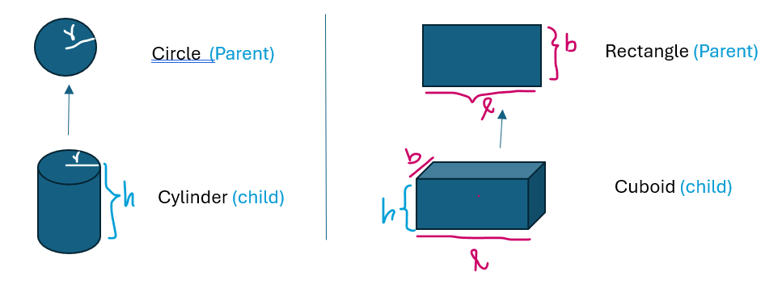
- All members of a Super class are available in Sub class, but all are not accessible.

Constructors

Class Test {
PSVM {
Class Rectangle{
private int length;
private int breadth;

Rectangle r= new Rectangle(5,10);
r.setLength(5);
r.setBreadth(10);
}
}

Here, when I create a Rectangle object itself, need to set the length & breadth , they should not be 0 initially; don’t want to set them afterwards.

- Methods used to initialize the properties at the time of construction of objects
- Constructor – mtd of a cls which is automatically called whenever an obj is created
- Every cls in Java – ‘ve some Default Constructor provided by Java compiler. If u define ur own constructor, own is taken & default will be removed.
Constructor –
- A Mtd which have same name as that of Cls name
- A mtd usually ‘ve a return type, but constructor won’t ‘ve a return type (won’t write even void)
- Constructor r gnrl’y declared Public , if needed can make it Private too

Types of Constructors :
Non- Parameterized Constructor
- Does not take any parameter or arguments
- w/o parameter , may be replacement of default constructor
public Rectangle( ){
length=1;
breadth=1;
}
Parameterized Constructor
- With parameter
public Rectangle( int l, int b){
length= l;
breadth=b;
}

- Constructors can be either parameterized or non-parameterized
- Constructors can b overloaded ie., can create as many cons’r as possible- wid diff parameters or arguments

Constructors in Inheritance
When we create an Obj of Child cls, Parent cls constructor is executed first & then the child cls constructor
Whatevr the levels of Inheritance we ‘ve done, when we create an obj of some cls, then the Constructor of Topmost cls in the levels ‘ll be executed first; then the nxt level & then next.
Constr r executed from top towards bottom.

Eg., in automobile engineering, Parent cls- platform ; child cls- cabin
In the same way, in inheritance, 1st parent cls obj created; then it is extended to child cls obj
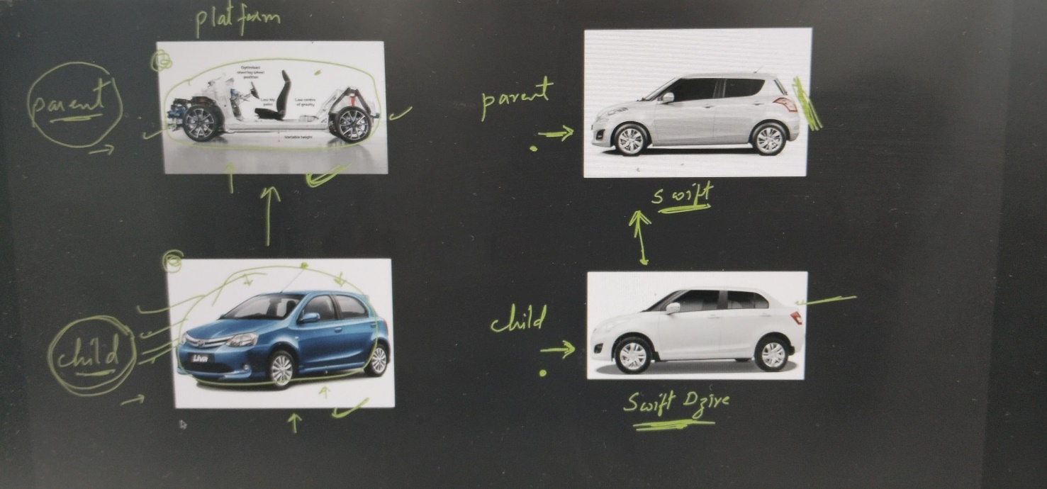

Parameterized Constructors
When we call a non-paramaterized constr of child,

When we call a paramaterized constr of child,

How to call the Parameterized Constr of Super cls ?
It must be called from the Constr of Child cls by using keyword ‘super’
Note: This call to parent param constr line must be the 1st line !
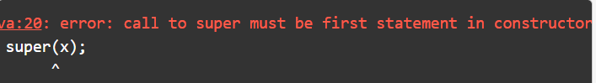

‘ super ‘ keyword
- to refer to the immediate parent (superclass) of the current object.
- It allows you to access members (fields, methods, constructors) of the superclass from a subclass.
Usage:
- Calling Superclass Constructors:
super() - to invoke a constructor from the superclass, and it must be the first statement in a subclass constructor.
If the superclass has a constructor with arguments, call it using super(arguments).
- Calling Superclass Methods:
super.methodName() - to call a method from the superclass that has been overridden in the subclass.
- Accessing Superclass Fields:
super.fieldName - to access a field (variable) from the superclass, especially if the field is hidden by a variable of the same name in the subclass.
- Constructor Chaining:
super() is used for calling the constructor of a superclass,
super() constructor call is implicitly called if no other constructor is defined in the subclass, but you can also explicitly call a superclass constructor. If you want to call a specific constructor in the superclass, you can use super(arguments).
Constructor chaining ( calling a constructor of the same or superclass ) is useful for initializing objects in a sequence.

- Avoiding Ambiguity
- The super keyword helps to avoid ambiguity when a subclass method or field has the same name as those in the superclass. It explicitly distinguishes between the subclass and superclass members

‘this ‘ keyword

Instance vs Local Variable
Instance variable:- These variables are declared within a class but outside a method.
- These variables are created when we create an object and are destroyed when the object is destroyed. (scope: particular instance / obj)
Local variable:- These variables are declared within a method but do not get any default value.
- They are created when we enter a method or constructor and get destroyed when the call returns from the method. (scope: particular mtd/ constr/ block)

In Java, it is not allowed to declare two or more variables having the same name inside a scope either in class scope or method scope.
- When both local & instance var‘ve same var name, preference is always given to local var.
Val gets assigned to local var, instead of instance var.
- Creating an object is not a good idea to solve the issue of conflicting names of instance and local variables.
- We can differentiate between local and instance variables by passing an object itself.
- Instead of writing and passing an object, we can simply use ‘this’ keyword.

“this “ keyword – reference (variable) that refers to the current object.

Usage of Java this keyword
- this can be used to refer current class instance variable.
ie., parameters (formal arguments) / local var and instance variables are same. When they have name conflicts b/n properties & parameters, Use this keyword to refer to properties/ data members of the cls.
- this can be used to invoke current class method (implicitly)
ie., to call another method within the same class.
- this() can be used to invoke current class constructor.
ie., to call another constructor within the same class- constructor chaining.
- this can be passed as an argument in the method call.
ie., passed as an argument to other methods to refer to the current instance.
- this can be passed as argument in the constructor call.
- this can be used to return the current class instance from the method.

Ref- https://www.javatpoint.com/this-keyword
Code- https://www.onlinegdb.com/edit/tM_kS2NaX

Feature | this | super
Refers to | The current instance of the class / current obj | Reference to the superclass of the current class
Usage | Used to refer to instance variables, methods, or constructors within the current class | Used to access methods and constructors from the parent class
Constructor Call | Can invoke other constructors in the same class (using this()) | Used to invoke the constructor of the parent class (using super())
Access to Members | Can access current class instance members | Can access parent class members
Method Invocation | Invokes methods of the current class | Invokes methods of the superclass

Array Of Objects

- Array of objects stores objects ie., objects r stored as an element of an array.
- Only the reference of the object – stored in array not the object itself.
Syntax:
Cls_Name obj[ ] = new Cls_Name[ Array_Length] ;

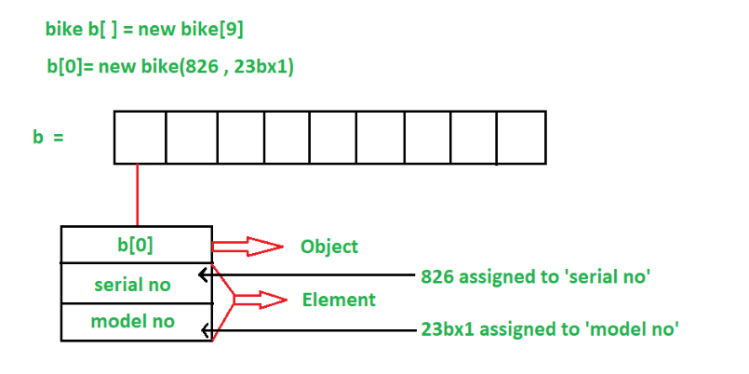

Polymorphism
Poly- many, morphism- forms one name, diff actions
In Java, Polymorphism achieved using – Mtd Overloading & Mtd Overriding.

Method overriding and overloading are the two major concepts of object oriented programming. Both are the ways of implementing polymorphism.

Method Overloading
  - Two or more mtds with same name, but different parameters exists in the same cls.
Here, which mtd to call – decided by the no.of arguments & type of arguments
Method overloading is a form of compile-time polymorphism, ie., compiler decides which method to call based on the method signature (name and parameter list). (like its pre-defined)

Method Overloading – achieved within the same cls & it can be across the cls’s also (ie., in child cls )
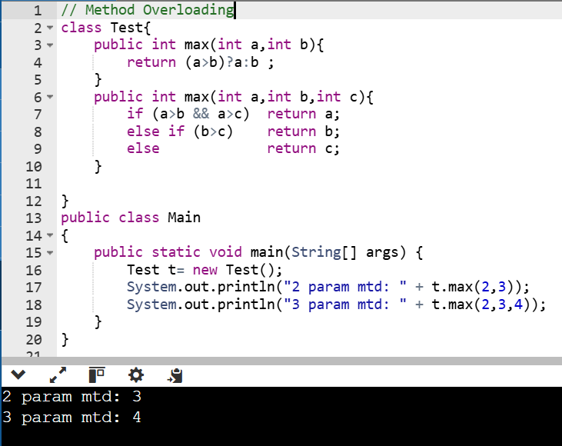

Method Overriding
  - Re-defining a mtd of a Super cls in a sub cls; a subclass provides its own specific implementation of a method that is already defined in its superclass.
Enables a subclass to inherit the method from the superclass but override it to perform a different task.
The overridden method in the subclass must have the same name, return type, and parameters as the method in the superclass. (signature ie., name, parameters.. must be the same )
When access overridden mtd by a sub cls obj, The spr cls mtd with same name – hidden / shadowed, only the sub cls mtd – visible.

Mtd Overrriding – achieved only in Inheritance ie., between a Spr cls & Sub cls.
for achieving runtime polymorphism, where the method that gets called is determined by the actual object type at runtime (why runtime ? bcoz obj gets created at the runtime, so compiler cannot decide w/c mtd to cll ), not the reference type.

Super sup = new Sub();
Sup.display(); //here, sub cls mtd is called, as mtd is called only upon Obj , not Reference
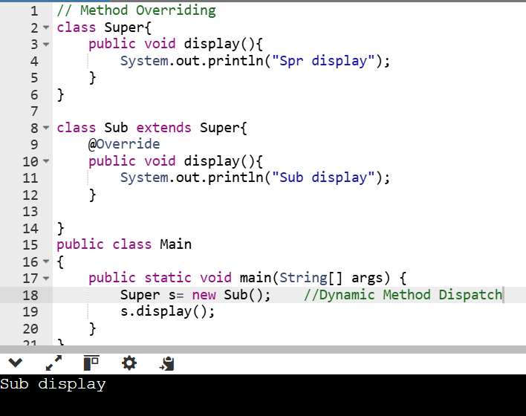

Dynamic Mtd Dispatch
Used to achieve Runtime polymorphism using Mtd Overriding.
When a Spr cls reference holding a Sub cls obj & Overridden ( redefined ) mtd is called, then mtd of Obj ‘ll b called ; not the mtd of reference.
Note: only can ‘ve Spr cls – Ref, Sub cls – obj….other ways not allowed
  - A Spr cls ref can hold Obj of Sub cls ; but it can call only those mtds that r avail in Spr cls. ( cannot call own extra mtds of Sub cls)

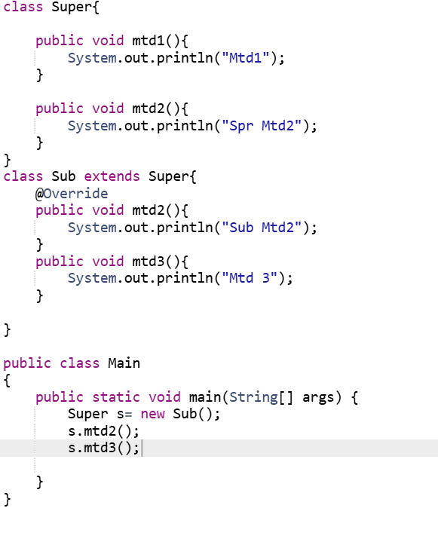
With spr cls reference,as it knows only mtd1,2…can call only those
If mtd1 called with Sub obj, ‘ll b borrowed from Spr cls
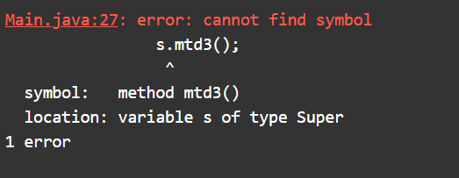

Rules for Overriding
  - Parameters of mtds must be same. ( if not, they r diff mtds )
  - As java – case sensitive, names must be same. (if not, comes under Mtd overloading)
  - Return type -same
Exception: Return type can be Diff, when Spr cls return obj of Class A, then Overrided mtd can return obj of its ie., A’s sub cls / its own cls.

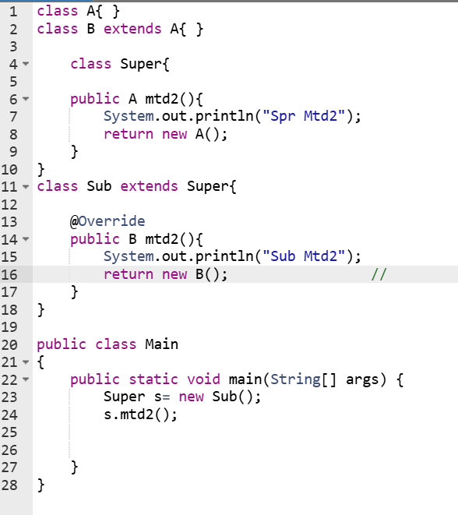
public B mtd2() {:
This overrides the mtd2() method from the Super class. In Sub, the return type of mtd2() is B, which is a subclass of A. This is allowed because B can be returned in place of A, as B is a more specific type.

  - Static & Final mtds cannot be overrided.

Tv & SmartTv eg., for Mtd Overloading & Mtd Overriding
Code - https://www.onlinegdb.com/?dest_fid=54011575

Abstraction
Process of hiding the implementation details and only showing the essential functionality or features to the user.
This helps simplify the system by focusing on what an object does rather than how it does it.
  - In Java, abstraction is achieved by interfaces and abstract classes.
We can achieve 100% abstraction using interfaces.

Abstract Classes
Two types of classes :
- Abstract cls - cls declared with ‘abstract ‘ keyword
- cannot create obj’s of abstract cls’s ; but can have a reference
Super s1;
s1= new Super();

- Concrete cls - normal classes we r wrk’g with
- can create obj’s of concrete cls’s ; can have reference as well
Sub s= new Sub();
Abstract Method : Any undefined mtd not having mtd body, just ended with ‘ ; ‘ ( ie., no { …} ) - must be declared ‘abstract’
Abstract Class : Cannot create obj of abstract cls
If a class have atleast 1 abstract mtd , then cls is also abstract
( b/c if something is not defined inside the cls, then cls itself is not completely defined cannot create obj )
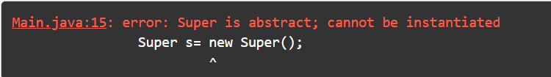
- A cls can be abstract with or without abstract mtds, if any abs mtd present, cls must be made abstract.
Purpose of Abstract cls – only for Inheritance
- If a class is inheriting from abstract class, then it will also become an abstract.

To become a concrete cls, it must override all the abstract mtds of that class (ie., Super class/ parent class )
It must override all the methods.Then it becomes concrete, its object can be created.

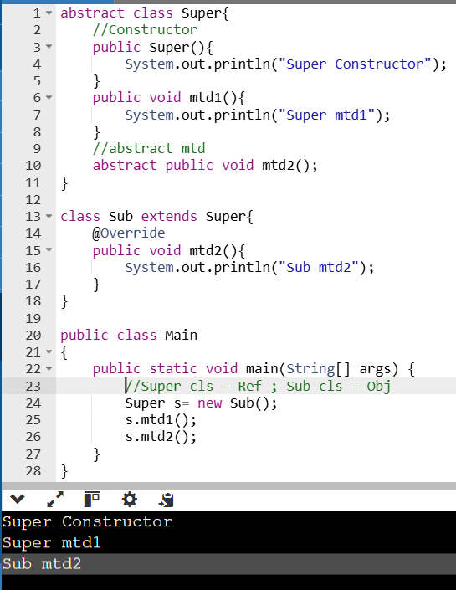

Rules for Abstract cls & Mtds
- An abstract cls can have Reference, but cannot create an Obj of abstract cls.
- If there’s no body for any mtd, it s/d b made abstract.
- If a class is having at least one abstract method , then class must be declared as abstract.
- Abstract classes cannot be final.
final means if a class is final, then it cannot be extended.
As abstract classes are meant for inheritance only. So if you make final, then it cannot be extended. So it is not all valid. It's meaningless.

- Abstract Mtds cannot be final.
when you make a method as final, you cannot override it. But abstract mtds are meant for overriding only.

- Abstract cls & mtds cannot b static.
static method means it must have its body. We can call it without a object just by using a class name.

- If there’s a sub class that extends super class, then it must override abstract methods.Otherwise, the class become abstract.



Eg 1., Hospital
//concrete Sub cls – following those std’s,
When we build a new hospital
Class myHospital extends Hospital{
myHospital() { … }
void emergency() {… }
void appointment() { … }
…
}

Hospital h= new myHospital();
h.admit(); //mtd of sub cls called

// abstract Spr cls –a body for imposing std’s,
Won’t actually ‘ve their hospital
abstract class Hospital{
abstract void emergency();
abstract void appointment();
abstract void admit();
abstract void billing();
}

Eg 2., Shape
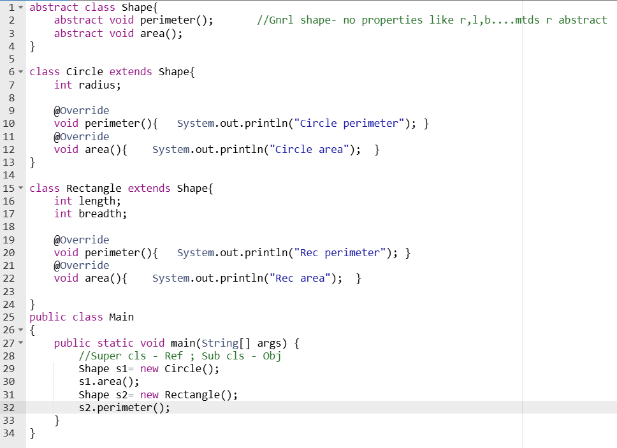

Interfaces

Inheritance – a class can be extended from an existing cls, borrowing all the features. (spr , sub cls’s)
Abstract classes – A class having one or more abstract mtds, purpose: can achieve inheritance as well as polymorphism.
Interface is completely used for achieving polymorphism.It doesn't ‘ve anything to give to the subclasses.
So if we want to achieve only polymorphism, we don't want to borrow anything, then we use interfaces.
Here, class Test1 is abstract cls with abstract mtds 1,2. Cls Test2 extends from Test2, so it must override all abstract mtds to be concrete. Now, Test2 b/m concrete class, and Test1 remains a abstract class.
So this abstract class doesn't have anything to share with the subclass.It forces the subclasses to override all its methods. Here, purpose of that abstract class is only to achieve polymorphism.So when you have such an abstract class, instead of writing a class, we should write interface.
interface Test1{
public void mtd1();
public void mtd2();
}
class Test2 implements Test1{
public void mtd1() {….}
public void mtd2() {….}
}

abstract class Test1{
abstract public void mtd1();
abstract public void mtd2();
}
class Test2 extends Test1{
public void mtd1() {….}
public void mtd2() {….}
}

Test1 t= new Test2();

Interface – simply Abstract cls with all Abs mtds; Interfaces r implemented ( not extended )
In Abs cls, can ‘ve Spr cls reference & obj of sub cls.
for interface also, we can ‘ve a reference of that interface (obj cannot be instantiated as they r abstract ) & object of a class which is implementing an interface.
In java, A class can extend from only one class
When a class is implementing interface, it can implement multiple interfaces. ( ie., more than one interfaces )

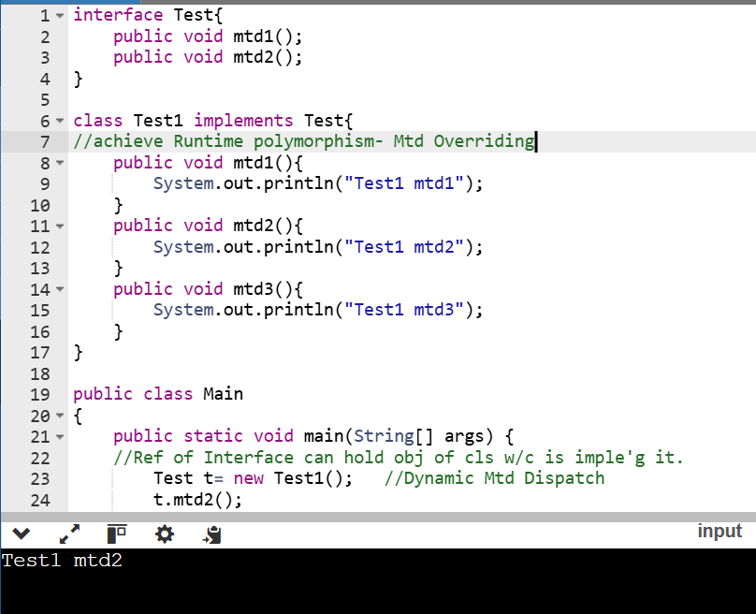

Smartphone Eg., - a class extends from only one class & implement from multiple interfaces.
Here, cls Smartohone borrows all features from cls Phone like voice, sms; also it has own mtd ‘videocall’. And overrides all mtds of Camera & Musicplayer interfaces.
class Phone{ //concrete cls
void call() {…}
void sms() {…}
}
interface Camera{
void click();
void record();
}
interface Musicplayer{
void play();
void pause();
void stop();
}
class Smartohone extends Phone implements Camera, Musicplayer {
void VideoCall() {….}

void click() {..}
void record() {..}
void play() {..}
void pause() {..}
void stop() {..}
}

Smartphone s= new Smartphone;
Phone p= s;
Camera c= s;
Musicplayer m= s;

Here, can create Obj Smartphn cls with Smartphn cls as reference, then all mtds r accessible. When we create obj of Smartphn cls with separate references, then only mtds of that particular ref will b accessible.
Code - https://www.onlinegdb.com/edit/mndXXeu2v

Cmn usage of Interfaces – used for defining ‘ callBack ‘ mtds
callback mtds r used in Event handling.

Keypoints Interfaces
- In Interfaces, by default the mtds r public & abstract
- Cannot make mtds as private, as they r supposed to be implemented by classes.
- Can ‘ve variable in an interface, Make identifier Uppercase (preferred ) & by default they r final & static.
Members of interface are always declared as const, their values are final
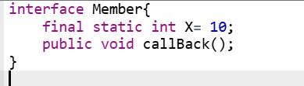

- by default, the methods inside an interface are abstract and they cannot have body.
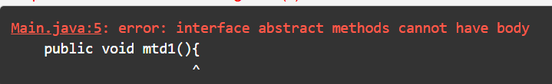
- Interface can have static methods also with body.

Can access this Static var & mtds with interface name from main mtd, w/o creating obj
- Interfaces can be extended
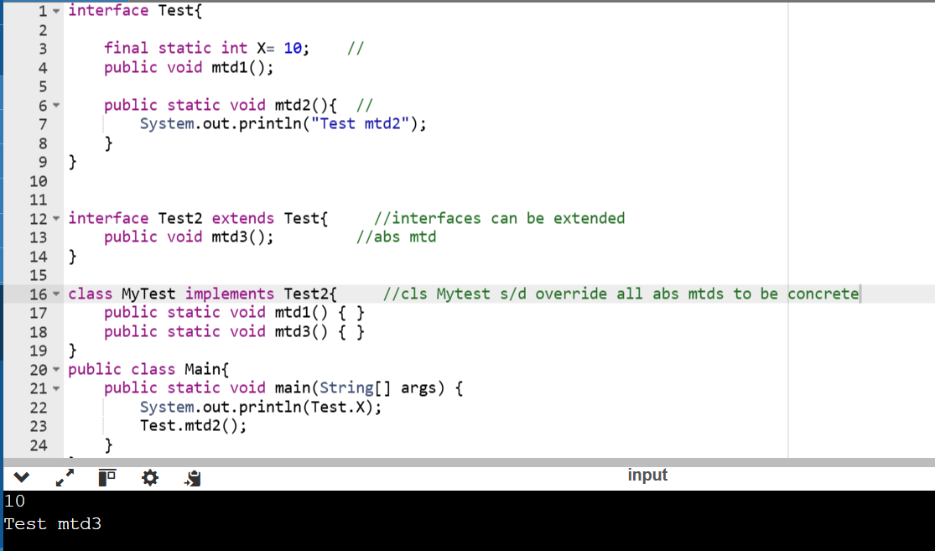
- to update or modify existing interfaces w/o disturbing existing classes, use default methods.
Existing classes will get the default method & in a new class you can override the method.



- declare method of the interface as private ; can write private mtds w/c r not abstract inside interface ; ‘ll b used internally inside interface.

Interface Vs Multiple Inheritance
C++ supports Multiple Inheritance [ a child cls inherits from more than one parent cls ]
Eg., say Smartphn is a phn / a camera/ a musicplayer
In Java, a child cls can extend from only one parent cls . Mutiple inheritance achieved using Interface.
Eg., Smartphn is a phn that has features of Camera & Musicplayer
Here, Smartphn inherits from Phn cls & implements Camera interface & Musicplayer interface.
Eg2., Suziki – a car , ‘ve Musicplayer

Inner Classes
- Define a class inside another class ie., outer cls ‘ve a inner cls inside. (Nested class)
- Also, can define an interface inside a cls
Need of inner cls : to reduce complexity of bigger cls, we define a cls inside it.

Types of Inner classes
- Nested Inner class
- Local Inner class
- Anonymous Inner class
- Static Inner class

Nested Inner class:
- Inner cls can access the members of outer cls directly
- Outer cls cannot directly access member sof inner cls, unless it created an obj of inner cls.
- Can access inner cls outside outer cls (but useless ) by creating obj of inner cls.
Cannot directly refer to inner cls w/o outer cls [create obj of outer cls, create obj of inner cls with dot opr ]

Code: https://www.onlinegdb.com/edit/sglBHCM92

For every cls in java, separate cls file ‘ll b created.
Outer cls Outer . class
Inner cls Outer $ Inner . class (as inner cls is associated with outer cls )

Local Inner class:
Inner cls inside a mtd ( can define a cls inside a mtd also) ; this cls is visible & useful only inside that mtd.
outside this method, that class, this class is not visible. So it's local to the method.
If any cls need to inherit from an existing cls or implement an interface; s/d be visible only inside the mtd , not outside the mtd - define Local Inner cls.
Code: https://onlinegdb.com/th5_vksPH

Anonymous Inner class:
- A local inner class without name. An anonymous class is defined and instantiated in a single statement.
- They can be defined at the time of creation of Obj itself ; can define the class as well as create an object.
- Useful for Interfaces & Abstract classes
For abs cls, can ‘ve Reference , but cannot create obj.
Here, we r defining a class that overrides the Abs mtd of Abs cls & we create an obj.
This obj is not that of Abs cls, but we r using the same name of Abs cls.
So abstract class object cannot be created, but we have overrided the method. So compiler will create a nameless class ie., anonymous class
and its object will be created and Abs cls will be the reference.
We can override the abstract methods of abstract classes, as well as, we can implement interfaces using anonymous classes.
- Can only extend exactly one class or implement exactly one interface
- Anonymous InnerCls – can access members of outer cls

Static Inner class:
- Static inner classes r the static members of the outer class.
- Can create obj of Static inner cls outside the Outer cls , w/o creating obj of outer cls.
[ Unlike Nested Inner cls, w/c r dependent on outer cls & r not directly accessible w/o obj of Outer cls ]
- Static Inner cls can access only Static members of outer cls ( cannot access non-static members of outer cls )

Static
Static
- Static keyword – used for representing metadata [ Metadata – data abt data ie., class ]
- Static members r useful for representing data related to cls, not abt the obj’s ( though all obj’s can use that data )
- static members r used as shared data among all the obj’s- if any obj change the val, it’s visible to all other obj of that cls.
- Can access static members with Class name w/o creating obj’s. [ they exist even if obj’s r not created ]
Eg., we no need to buy a car ( creating obj ) to just know the price ( as price var is static )
- Static members of a cls r created inside ‘Mtd area’ in memory (independent of obj’s ) – they r avail once the cls is loaded.

Static Variables Use , if we ‘ve only data related to cls
- Static variable belongs to a class.
- It can be shared by all the objects.
- There will be only one copy or instanceof a static variable, common for all the objects.
- They r created in mtd area & used as shared data member by all the obj’s
- They can be accessed with Class name as well as Obj name

Static Methods If that data needs some processing & ‘ve to do some computations, then make it as a method.
- Static mtds belong to cls & they r cmn to all obj’s
- Can b called by ‘Cls name’ ; w/o creating obj’s also
- Static Mtds can be Overloaded & cannot be Overrided.
- Static mtds can access only static members ( ie., Static var’s / other static mtds ) ; cannot access non-static members of cls
But , non-static members can access static members of cls

Eg., if you want to know the onboard price (Road tax + Insurance ; differs from actual car price in showroom ) of a Honda City, you don't have to buy it,
first you go to showroom and inquire.They'll give you the details.
Then if you want to buy, you can buy it or not,that's your choice.
But on-road price is the information about a class. No need to create obj.
Code : https://onlinegdb.com/nESjAzjVO

Static Nested class if you have a lot of data or mtds , grp them in a class.
**Ref @Static Inner class
- If we ‘ve multiple static mtds, can grp them into a cls & make that cls as Static.
- Only Inner cls’s can be static , not the outer cls.
- Can create obj of that Static cls outside , independent of the outer cls.
- Cannot access non-static members or instance members ( obj members ) of the class.
- Mtds or static mtds inside static cls cannot use keywords “this” , “super” as they refer to a instance / obj.

Static Block here, we write a set of statements as a block & make it as static.
These set of statements will be executed once the class is loaded before the creation of obj’s of that cls.
Use: Initialize / setup only static things inside a static block.
- Inside a static block, can access only static members of the cls (ie., static var / mtds)
- There can b more than 1 static blocks in a cls, they r executed in the order we defined.
Cannot define static blocks inside main mtd.

Final
Final – like a const . They can be used, but cannot be modified/ extended/ overrided.
Final Variable To create Constant variable ( eg., define a const var like PI= 3.14 )
like const var, their val r fixed & cannot be modified once initialized
- Notation for Final var – Uppercase (eg., final int MAX = 21; )
- Final var initialized in 3 ways :
- Direct initialize or declare & initialize later (but cannot be used w/o initializing ) allowed only inside mtd [ as a member of cls , must be initialized in single line ]
- Inside a static block ( final var belong to cls, can b initialized inside a static block, only if they r static )
- Inside a constructor of the cls

Final Method Prevent Mtd Overriding
Final mtds cannot be overrided, can ‘ve subcls that is inheriting from the cls; but cannot redefine a final mtd. ( restricts run-time polymorphism )
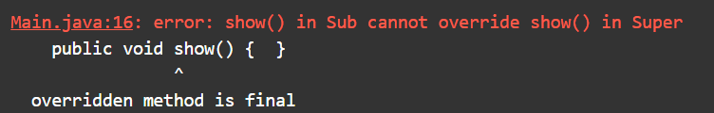

Final Class Prevent Inheritance
A final cls cannot be extended, can create obj & use it ( but cannot inherit / borrow features of that cls )


Code : https://onlinegdb.com/GVUttm91Rf

Singleton Class
A cls w/c can create only one Obj (ie.,single obj), creating >1 obj is not allowed.
If object of a class is used at different places, then that same single object should be used.
Eg., In ofc, there ‘ll b one Coffee machine, all employee/ staff use that one.

